**Condensed Chapter Material**

**Neurological System**

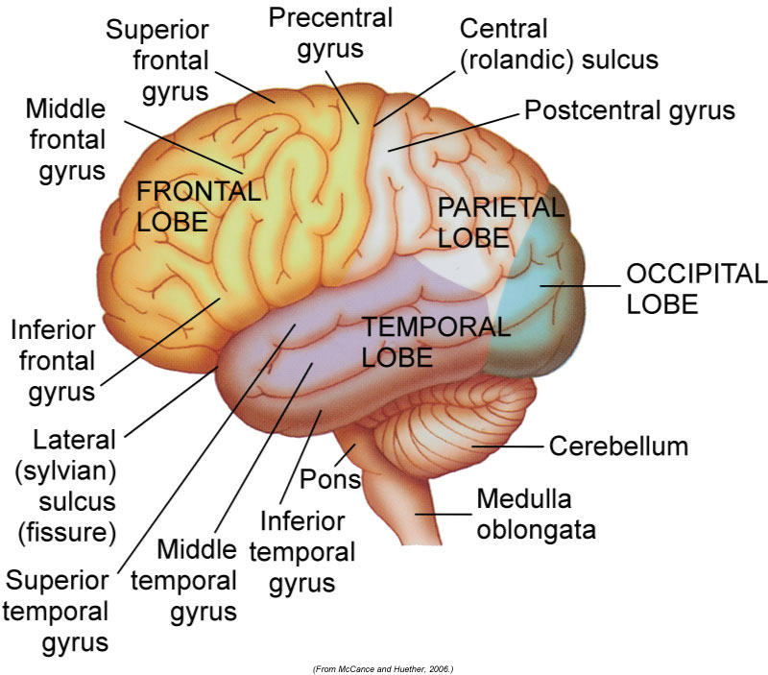

**1. Identify the basic components and functions of the cerebrum, cerebellum, and brainstem.**

Components of the brain:

1) **Cerebrum:** Includes the outer portion of the brain and many subcortical structures (e.g. basal ganglia). Composed of two cerebral hemispheres and each hemisphere is divided further into lobes (e.g. temporal, parietal, occipital and frontal).

Frontal lobe-includes motor cortex which controls movements of eyes, skeletal muscle and fine repetitive movements.

Parietal Lobe-Processes sensory information.

Occipital Lobe-Includes primary vision center.

Temporal Lobe-Involved in perception and interpretation of sounds. Involved in sensory integration. Contains speech center (Wernicke’s area).

Basal ganglia-functions as extrapyramidal (movements that are involuntary) and processing station between cerebral motor cortex and upper brainstem. Refines motor movements.

2) **Cerebellum**-aids the motor cortex in the integration of voluntary movement by processing sensory information. Acting jointly with the vestibular system, uses sensory information for reflexive control of muscle tone, balance, and posture to create steady and precise movements.

3) **Brainstem**-connects cerebral cortex to spinal cord. Gives rise to the cranial nerves. Composed of midbrain, pons, medulla oblongata and diencephalon. Diencephalon is made of :

- thalamus (major integrating center for sensations

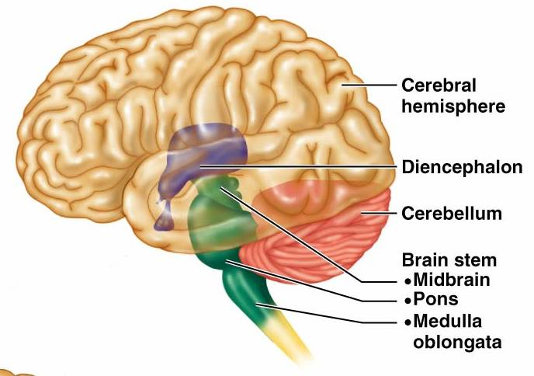

like pain and temperature)

- epithalamus (sexual development and behavior)

- hypothalamus (temperature control, feeding behavior,

neuroendocrine activity)

- pituitary gland (hormone control of growth, lactation, etc.).

Respiratory centers are located in medulla and pons. To further understand basic functions of brainstem, learn the functions of the cranial nerves that originate in specific areas of the brainstem (see below). (5, 6,7,8 who do we appreciate? Pons! Pons! Pons!).

**2. Describe the basic function of each cranial nerve and demonstrate how to evaluate its function. For demonstration of testing, watch videos!**

*Note: Cranial nerves are peripheral nerves that arise from the brainstem. There is minimal overlap, and therefor each can be assessed with specific exam maneuvers, which we’ll learn in class. For class prep, be familiar with the function of each cranial nerve and how it’s tested.*

|  |  |  |
| --- | --- | --- |
| Cranial Nerve | Function | Test |
| CN 1 (olfactory nerve) | Sensory: Smell reception and interpretation | Test: Have patient identify familiar odors with eyes closed and testing one naris at a time. |
| CN II (optic nerve) | Sensory: Visual acuity and visual fields | Test: Examine patients near and far sighted vision and peripheral fields. |
| CN III (oculomotor) | Motor function: Raises eyelids and most extraocular movements | Test: Shine light in right eye and should see constriction in both the right and left eye. Repeat with other side. Test accommodation by having the patient following your finger while your move it towards them directly in the middle-should see eyes converge and constrict to increase focus. Inspect eyelids for drooping.  (See text box below ) |
| CN IV (trochlear) | Motor function: downward, inward eye movement | (See text box below) |
| CN V (trigeminal) | Motor function: jaw opening, clenching, and mastication  Sensory function: sensory to skin of the face, cornea, iris, eyelids, nasal and mouth mucosa, teeth and tongue | Observe for any facial muscle atrophy, jaw deviation, or fasciculations (twitches).  Have patient clench teeth and palpate the muscles over jaw for tone. Touch each side of patients face (from scalp to chin) and have he or she to assess if sensation feels the same on both sides. |
| CN VI (abducens) | Motor function: lateral eye movement | Test: See text box |
| CN VII (facial) | Motor: Facial expression muscles, close eyelids, speech involving lips | Test: Have patient make facial expressions like raising eyebrows, squeezing eyes shut, frown, show teeth, puff cheeks, and purse lips. Look for any asymmetry, tics, drooping of mouth, flattened nasolabial folds. |
| CN VIII (Acoustic) | Sensory function: Hearing and equilibrium | Vestibular function tested with balance test.  Hearing is tested by screening tests or with audiometer. |
| CN IX (Glossopharyngeal) | Sensory: nasopharynx (gag test), taste in posterior one third of tongue.  Parasympathetic: secretion of parotid gland | Touch back of mouth with tongue depressor and evaluate sensation. |
| CN X (vagus) | Motor: Supplies motor innervation to pharynx, soft palate and larynx | Have patient say “ah” and look at the palate and uvula movement. Should see symmetrical palate elevation. |
| CN XI (spinal accessory) | Motor: turn head, shrug shoulders | Function: Have patient shrug shoulders and turn head to each side against resistance. |
| CN XII (hypoglossal) | Motor: tongue movement | Ask patient to stick out tongue and move from side to side. |

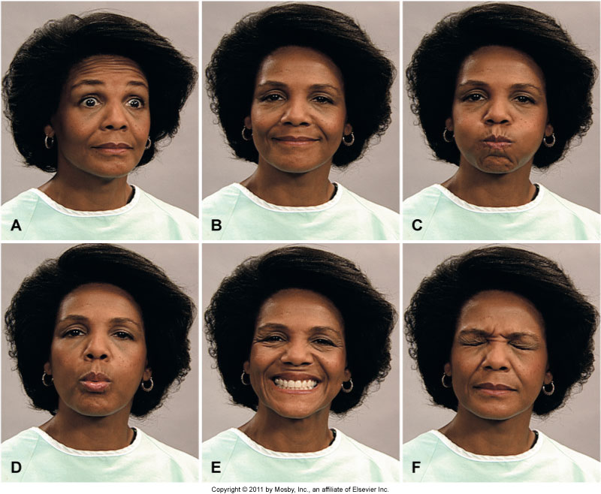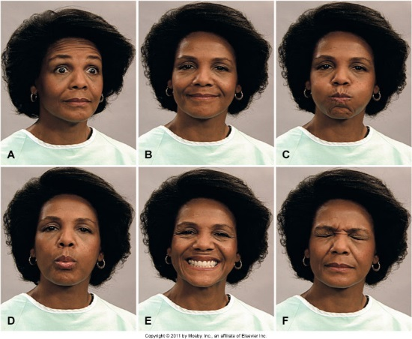

[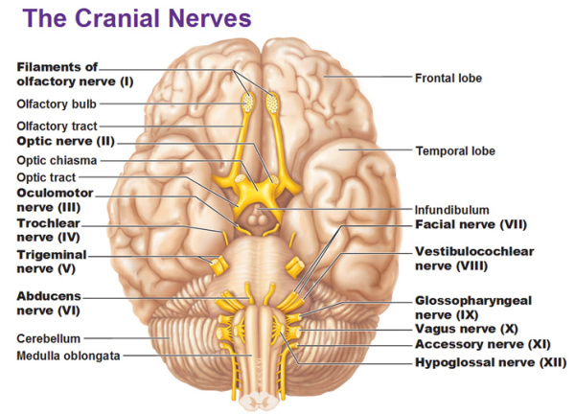](https://themdhub.files.wordpress.com/2013/10/cranial-nerves-3.jpg)

*You will memorize all this soon. For now, note that cranial nerves are peripheral nerves that arise from the brain. This diagram highlights the location of the nerves in relation to the midbrain.*

You will

Can test the motor functions of CN III, IV and VI at the same time by having patient follow your finger with their eyes through the six cardinal points of gaze (patient’s head should be still). Note: the small numbers represent the CN involved.

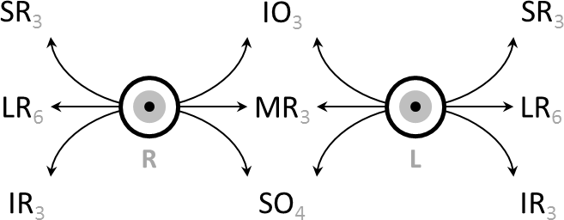

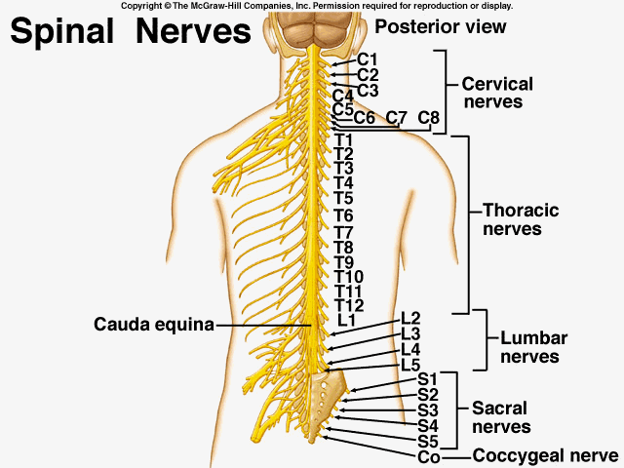3. **List the number of spinal nerves for each spinal division.**

There are 31 spinal nerves.

Cervical: 7 vertebral segments and **8 spinal nerve pairs (C1-8)**

Thoracic: 12 vertebral segments and **12 spinal nerve pairs (T1-12)**

Lumbar: 5 vertebral segments and **5 spinal nerve pairs (L1-5)**

Sacral: 5 fused vertebral segments and **5 spinal nerve pairs (S1-5)**

Coccyx: 3-5 fused/unfused vertebrae and 1 coccygeal nerve pair

**4. Identify the dermatomes for basic landmarks including: nipples, thumb, index finger, pinky, umbilicus, anus, great toe, 5th toe.**

Dermatome is defined as the area of skin innervated by a single spinal nerve. 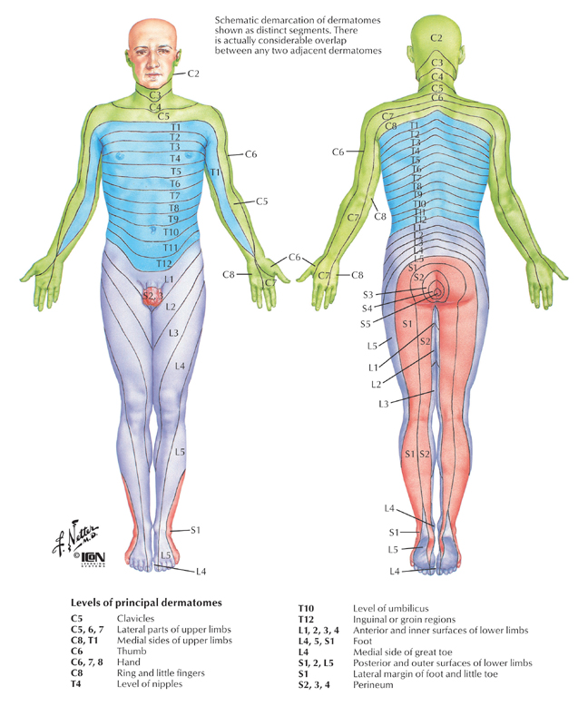Can help to localize spinal cord lesion. *Clinical correlation: herpes zoster (shingles) typically follows a dermatomal pattern.*

Nipples: T4

Thumb: C6

Index finger: C7

Pinky: C8

Umbilicus: T10

Anus: S5

Great toe: L4 (medial aspect) and L5 (lateral aspect)

5th toe: S1

**5. Demonstrate exam skills evaluating cerebellar function and proprioception**

**6. Demonstrate exam skills evaluating primary sensory functions**

Evaluating primary sensory function: have patient identify various sensory stimuli in different locations (hands, lower arms, legs, etc). *Patient’s eyes should be closed*. Start with minimal stimulation and increase gradually until patient can identify the stimulus. Compare sensation on both sides, and have patient describe stimulus (e.g. hot/cold, sharp/dull). If sensory deficit is appreciated, identify nerve involved (using information such as the dermatome involved)

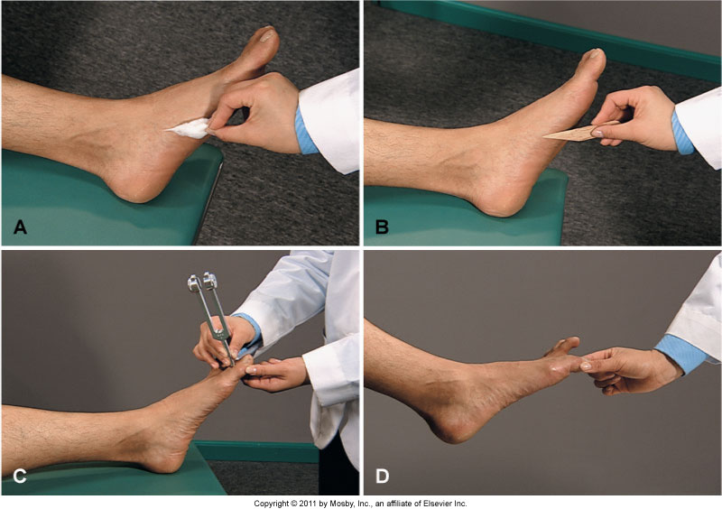

A) Superficial Touch-Lightly stroke using cotton swab or finger. Have patient identify when sensation is felt and compare bilaterally.

B) Superficial Pain-Break tongue blade and compare sensation between sharp (superficial pain) and smooth edge (superficial touch) in an unpredictable manner. Have patient identify each sensation (sharp/dull) and where the stimulus is felt.

C) Vibration-Place stem of vibrating tuning fork on boney prominence (begin with toe and finger joints as these are the most distal, but can use other joints). Have patient identify where vibration is felt.

D) Position of joint-Assess a finger and the great toe bilaterally. Start with joint in neutral position and bend the joint in any direction, holding the joint on the lateral sides to avoid offering a clue to positioning. Have patient identify direction the joint was moved.

**7. Explain appropriate examination maneuvers for assessing the superficial plantar reflex and the deep tendon reflexes**

Superficial and deep tendon reflexes are used to evaluate function of specific spine segmental levels.

Superficial plantar reflex (Babinski)

Use end of reflex hammer to stroke the foot starting from the lateral side of the heel to the lateral side of the ball of the foot and then across to the medial aspect of the foot.

Normal: plantar flexion of all toes (downward response)

Abnormal: dorsiflexion of the great toe with or without fanning of other toes = Babinski sign (Exception: normal in children younger than two). *Indicative of upper motor neuron (pyramidal tract) disease.*

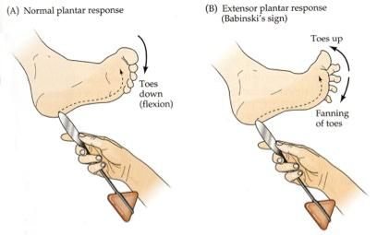

Deep tendon reflexes: Have patient in seated position or lying down. Can have patient focus his or her attention on an alternate muscle (e.g. pulling clenched hands apart) to prevent exaggerated or diminished response. Hold reflex hammer loosely between thumb and index finger and tap tendon with a flick of the wrist.

*Additional information: Absent reflex may indicate neuropathy or lower motor neuron disorder (e.g. spinal nerve). Hyperactive reflex suggests upper motor neuron disorder (e.g. nerves that synapse on spinal nerves to tell them when to fire).*

1) Biceps reflex: Flex patient’s arm to 45 degrees at the elbow. Palpate the biceps tendon (can have patient contract biceps to help you find the tendon and once found, have them relax again). Place thumb on tendon and strike your thumb with reflex hammer. Should see or feel flexion of the elbow.

2) Brachioradial reflex: Flex patient’s arm up to 45 degrees and rest their forearm on your arm. Strike the brachioradial tendon (1 to 2 inches above wrist) directly with reflex hammer. Should see pronation of forearm and flexion of elbow.

3) Triceps reflex- Flex patient’s arm at elbow to 90 degrees, supporting the arm proximal to the antecubital fossa. Strike triceps tendon directly with reflex hammer. Should see or feel extension of elbow due to contraction of triceps. 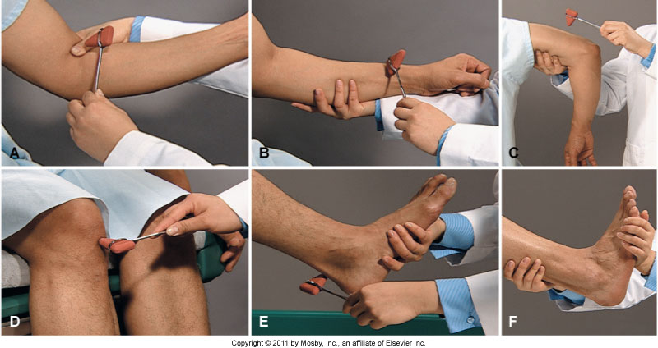

4) Patellar reflex-Have patient sit on end of the exam table with leg flexed at 90 degrees with lower leg hanging loosely. Strike patellar tendon (just below patella). Should see extension of lower leg due to contraction of quadriceps.

5) Achilles reflex-Have patient sit at end of the exam table with knee flexed at 90 degrees. Keep the ankle in a neutral position by holding their foot in your hand. Strike Achilles tendon at the level of ankle malleoli (bony prominences of ankle). Should see plantar flexion of foot (downwards movement) due to contraction of gastrocnemius muscle.

6) Clonus: Test for ankle clonus especially when reflexes are hyperactive. Support patient’s knee in partially flexed position and briskly dorsiflex the foot with other hand. No rhythmic oscillating movements between dorsiflexions and plantar flexion should be palpated.

**8. List the spinal nerve levels evaluated by the superficial and deep tendon reflexes**

Spinal Nerve Evaluated by Superficial Reflexes

|  |  |
| --- | --- |
| Plantar Reflex (“Babinski”) | L5, S1, and S2 |

Spinal Nerve Evaluated by Deep Tendon Reflex

|  |  |
| --- | --- |
| Biceps | C5 and C6 |
| Brachioradial | C5 and C6 |
| Triceps | C6, C7, and C8 |
| Patellar | L2, L3, and L4 |
| Achilles | S1 and S2 |

**Describe numerical grading of deep tendon reflexes**

Scoring Deep Tendon Reflexes

|  |  |
| --- | --- |
| **Grade** | **Deep Tendon Reflex Response** |
| 0 | No response |
| 1+ | Sluggish or diminished |
| 2+ | Active or expected response |
| 3+ | More brisk than expected, slightly hyperactive |
| 4+ | Brisk, hyperactive, with intermittent or transient clonus |

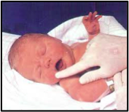

**Describe basic newborn reflexes**

Rooting Reflex- touch corner of infant’s mouth and infant will turn head and open mouth in the direction of stimulus. Present from birth to 3-4 months.

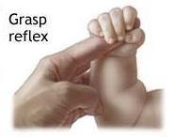

Palmar grasp- Touch palm of infant’s hand from ulnar side (pinky side). Should see strong grasp of your finger. From birth to 3 months (strongest at 1-2 months).

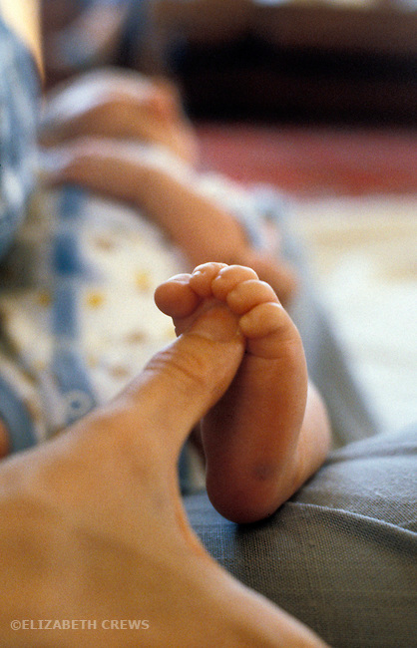Plantar grasp- Touch plantar surface of infant’s foot at base of the toes. Toes should curl downward. From birth to 8 months.

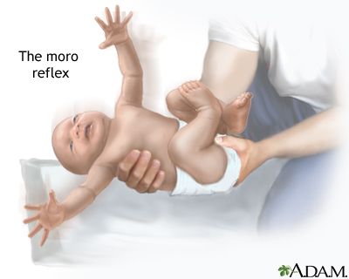

Moro- Have infant supported in semi seated position. Allow head and trunk to drop back to a 30 degree angle. Should first see abduction (spreading out of arms), extension of arms and fanning of fingers. Then should see adduction (unspreading of arms) and flexion of arms. Legs may have similar pattern. From birth to 6 months.

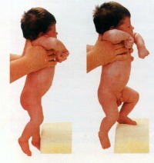

Placing--Hold infant under arms and touch the dorsal side of foot (top surface) on table edge. Should see flexion of hips and knees and lifting of foot (as if stepping up on table. Starts at four days and has variation of disappearance.

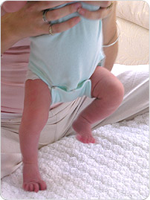Stepping- Hold infant under arms and touch the soles of their feet on the table. Should see alternating flexion and extension of the legs (as if he/she were walking). Starts between birth and 8 weeks and disappears before voluntary walking.

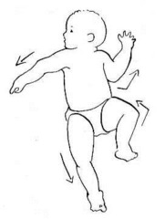

Asymmetric tonic neck (fencing) - Lay infant on his/her back and turn head to one side (with jaw over the shoulder). Should see extension of arm and leg on the side which the head was turned to and flexion of opposite arm and leg. Should see reversal of extremities when turning the head to the other side. From 2-3 months to 6 months (must disappear before rolling or bringing hands to face)